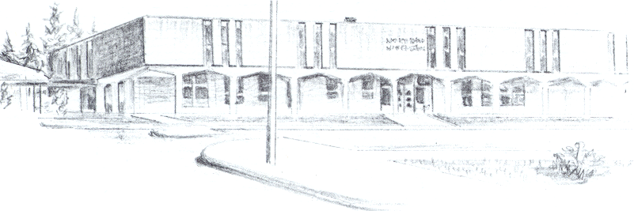

NORTH BEND HIGH SCHOOL
2323 Pacific Avenue
North Bend, Oregon 97459-2605
Telephone: 541-751-7159
Fax: 541-756-8322
A N I M P O R T A N T S C H O O L I N T H E N O R T H B E N D S Y S T E M O F P U B L I C E D U C A T I O N

To: Tom Welter
From: Mike Forrester
Re: Eric McDonald

Dear Tom:

North Bend High School supports the effort of Eric McDonald to participate in Track & Field this spring. Eric is a senior this year and has been a member of our school’s track team since he was a freshman. Eric is a very nice young man that made some poor choices with his study habits this past winter and only passed 4 classes. He needed to pass 5 to be eligible.

Looking back at Eric’s transcript, you will see that he has been a very good student at North Bend High School since he was a freshman. He earned nearly all A’s and B’s until the 2nd term of his junior year. When I talked to Eric about his lapse in grades, he took full responsibility for his poor study habits and lack of effort. Eric understands that if he is allowed to participate on our Track & Field team this year that he will have to be passing all of his classes at all times or he will be ineligible.

Sincerely,

Mike Forrester
North Bend High School
Athletic/Activities Director

