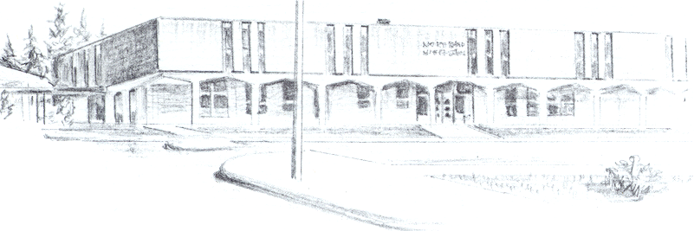

NORTH BEND HIGH SCHOOL
2323 Pacific Avenue
North Bend, Oregon 97459-2605
Telephone: 541-751-7159
Fax: 541-756-8322
A N I M P O R T A N T S C H O O L I N T H E N O R T H B E N D S Y S T E M O F P U B L I C E D U C A T I O N

North Bend High School supports the effort of Michael Streeper to participate in baseball this spring. Michael moved to North Bend High School with his mother from the state of Colorado. The transition was a tough one for Michael. We are hopeful that being involved in an activity here at school will help Michael in his adjustment to our school.

Michael has been a respectful young man while here at North Bend. His attendance is very good and he is a good citizen in our halls. We are monitoring Michael’s grades, and will continue to do so throughout the term to assure that he is not failing any classes. If Michael is allowed to play baseball, Michael will be monitored weekly to see that he is passing all of his classes and will not be allowed to participate if he is not.

Thanks for your consideration,

Michael R. Forrester
North Bend High School
Athletic/Activities Director

