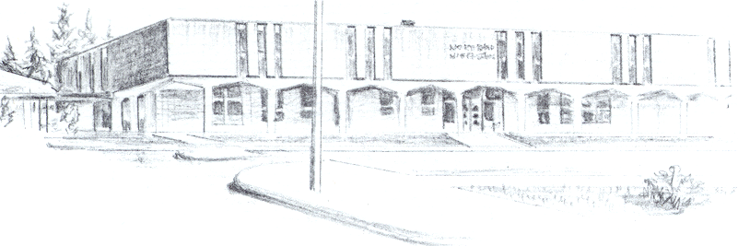

NORTH BEND HIGH SCHOOL
2323 Pacific Avenue
North Bend, Oregon 97459-2605
Telephone: 541-751-7159
Fax: 541-756-8322
A N I M P O R T A N T S C H O O L I N T H E N O R T H B E N D S Y S T E M O F P U B L I C E D U C A T I O N

North Bend High School supports the effort of Devon Carpenter to participate in spring sports at Marshfield High School. Devon attended school here in the fall and was on our soccer team. After the soccer season ended, Devon’s parents kicked him out of his house at which time he moved in with his girlfriend’s family.

At North Bend High School, we agreed to let Devon leave on an inner-district transfer after the fall because his living situation at home was not a positive one for him. I would be willing to share more information in needed, but I can tell you that the living situation was not a product of Devon simply not following rules. His parents created situations where he was not going to be able to succeed and then punished him for them. As an administrative team, we felt that there was a lot of mental and emotional abuse by his parents.

It would be a benefit for Devon to be able to participate in an activity at Marshfield High School.

Sincerely,

Mike Forrester
North Bend High School
Athletic/Activities Director

