From: Daniel Huld, Ed. D. [mailto:dhuld@bakercharters.org] Sent: Wednesday, March 16, 2016 12:45 PM To: Coplin, Steven Cc: Stephanie Hedin Subject: OSAA Participation

Steven,

Good afternoon. You can forward this email to the AD and that should clear Jordan for participation. Jordan is cleared to transfer from BWA. Spring semester grades are attached below. Per OSAA requirements he looks like he is cleared for participation in athletics with passing 6/6 classes on our last term with him in 14/15 spring semester. Thank you

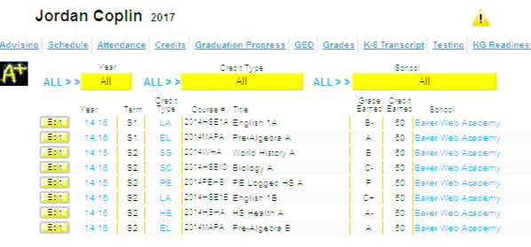

All the best,

Dr. Daniel Huld, Ed. D.
Director
Baker Charter Schools
503-929-3393 cell
503-200-1403 fax
Meeting Room Link
Schedule a Meeting Link

