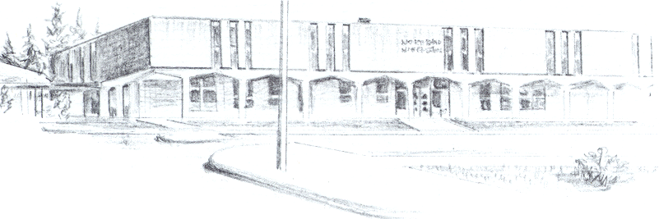

NORTH BEND HIGH SCHOOL
2323 Pacific Avenue
North Bend, Oregon 97459-2605
Telephone: 541-751-7159
Fax: 541-756-8322
A N I M P O R T A N T S C H O O L I N T H E N O R T H B E N D S Y S T E M O F P U B L I C E D U C A T I O N

To: Tom Welter
From: Mike Forrester
Re: Brianna Duff

Dear Tom,

North Bend High School supports the efforts of Brianna Duff to play golf this spring. Brianna has been a wonderful student here at North Bend. Coming into the winter term, Brianna only needed 7 credits to graduate from our Charter School, Oregon Coast Technology School. Because she knew she would only need to do 7 credits during the last 2 terms of school, Brianna only enrolled in 4 classes during the winter. What you won’t see on her grade report or on her transcript is that she worked at a job for 2 periods per day outside of school.

Having talked to Brianna, she did not understand that she had to be enrolled in and pass 5 classes in order to be eligible to participate in OSAA activities. She does understand that in order to participate this spring, she will have to be enrolled in and be passing 5 classes. Brianna simply looked at the number of classes she needed to pass in order to graduate and took those classes this winter.

Brianna is a wonderful young lady that is very hard working and has been a great citizen in our school for the last 2 years. We hope that Brianna is allowed to participate for our golf team this spring.

Sincerely,

Mike Forrester
North Bend High School
Athletic/Activities Director

