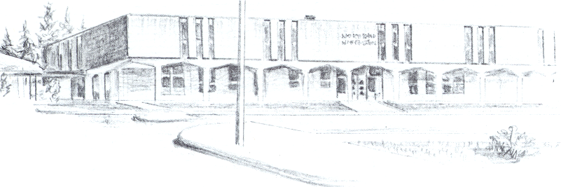

NORTH BEND HIGH SCHOOL
2323 Pacific Avenue
North Bend, Oregon 97459-2605
Telephone: 541-751-7159
Fax: 541-756-8322
A N I M P O R T A N T S C H O O L I N T H E N O R T H B E N D S Y S T E M O F P U B L I C E D U C A T I O N

To: Tom Welter
From: Mike Forrester
Re: Chelcey Cousineau

Dear Tom,

North Bend High School supports the effort of Chelsey Cousineau to participate in softball this spring. Chelcey is a junior and was not making “Adaquate Progress Toward Graduation at the start of this year. Chelcey wanted to play basketball during the Winter, but we did not believe that she had make enough progress to warrant a request for a hardship at that time. At this point, we believe that Chelcey has held up her end of the bargain and is on track to graduate next year. At the start of this year, Chelcey had only 24 credits, putting her 7 credits short of the 31 that we would require at North Bend High School to put her on track to graduate.

During the first 2 terms this year, Chelcey was enrolled in our PEAK program, which is a credit recovery program. She has acquired 20.5 credits already this year. She has done such a great job that she is going to go back into regular classes at North Bend High School for our third trimester. At the end of this year, Chelcey will have received 53 credits and will be back on track to graduate.

Chelcey is a homeless student that has had many hardships in her life. Her father left the family while she was very young, and several years ago, her mother was sent to the women’s state prison where she will be for many years. We believe that while Chelcey still faces many struggles, she has done a very good job in making a great effort to get her life going back in the right direction.

Sincerely,

Mike Forrester
North Bend High School
Athletic/Activities Director

