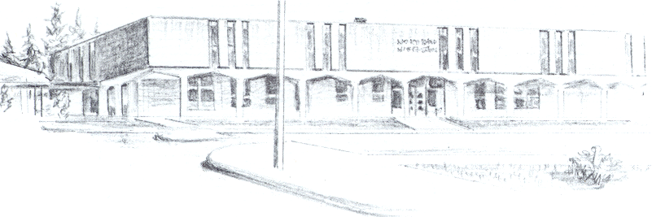

NORTH BEND HIGH SCHOOL
2323 Pacific Avenue
North Bend, Oregon 97459-2605
Telephone: 541-751-7159
Fax: 541-756-8322
A N I M P O R T A N T S C H O O L I N T H E N O R T H B E N D S Y S T E M O F P U B L I C E D U C A T I O N

To: Tom Welter
From: Mike Forrester
Re: Brad Haga Hardship

Dear Tom,

North Bend High School supports the effort of Brad Haga to participate in baseball this spring. Brad had a rough start to high school and failed a number of classes during his Freshman and Sophomore years. During the last 2 years, Brad has not failed any classes.

At the start of this year, Brad had 50 credits and was in need of 53 in order to be making adequate progress toward graduation. This past term, Brad receive 8 credits. This term, he has already completed a credit in a credit recovery class and I believe will have another one done before the end of the term. He now needs 13 credits in order to graduate. He has 7 classes this term and will take another 7 next term, so Brad will have enough credits to graduate as long as he passes all of his classes both terms.

Brad has evolved from a student who was very immature during his freshman and sophomore years into a very responsible young man that understands that his grade issues were caused by his poor choices and study habit. Brad has never come in and tried to say that his grade issues were anyone’s fault but his own. We support Brad in his desire to play baseball this season at North Bend High School.

Thanks for your consideration,

Mike Forrester
North Bend High School
Athletic and Activities Director

