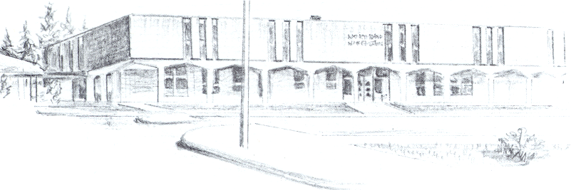

NORTH BEND HIGH SCHOOL
2323 Pacific Avenue
North Bend, Oregon 97459-2605
Telephone: 541-751-7159
Fax: 541-756-8322
A N I M P O R T A N T S C H O O L I N T H E N O R T H B E N D S Y S T E M O F P U B L I C E D U C A T I O N

To: Tom Welter

From: Mike Forrester

Re: Roger Iparraguirre

Dear Tom,

North Bend High School supports the efforts of Roger Iparraguirre to participate in basketball for the remainder of this season. It was discovered when I came back to work that Roger was an illegal participant in several basketball games. Those 2 games will be forfeited. Roger has been a good student here at North Bend High School. Until this past fall, Roger had never failed a class at North Bend High School. Even though I monitored his grades during the fall term, because he failed his final exams, he did not pass the required 5 classes.

We believe it is important for Roger to stay involved in athletics here at North Bend. He is a positive influence on the rest of his team mates and he benefits from being around them. I have attached Roger’s current grades as well. Roger has 4 passing classes and an N/A in 3 others, only because his teachers have not yet entered his grades for this term. I have talked to two of Roger’s teachers in the classes with an N/A and he is doing well in those classes.

At North Bend High School, we will monitor Roger’s grades throughout the season. Our policy here will be that if Roger is failing a class, he will have to sit until he is passing all of his classes again. Thank you for your consideration.

Sincerely,

Mike Forrester
North Bend High School
Athletic/Activities Director

