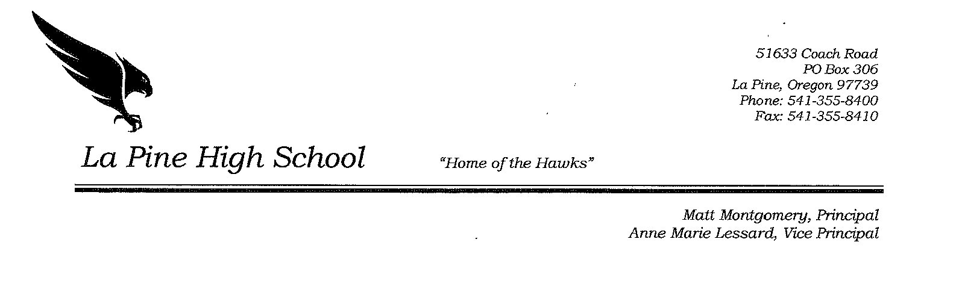

January 7, 2016

To Whom It May Concern:

On behalf of Marquis Stephens, I am providing information as to how he will get caught up and back on track for graduation.

Marquis is currently taking junior level core classes as well as an online class to recover credits. He will continue to be in the proctored online learning class at La Pine High School until he has completed the courses and credits he needs to be on track to graduate. We also have a summer school credit recovery program that will allow him to earn credits during the summer break if needed.

Marquis has been great to work with and is very motivated to earn the credits he needs. The teacher for his online class period reports that he is working very hard, earning an ‘A’ grade, and is ahead of schedule with his current online course.

I am confident that Marquis will continue to make the effort needed to get back on track for graduation and will meet or exceed the OSAA credit requirement to start his Senior year.

Sincerely,

Michelle McDaniel

Michelle McDaniel
Counselor

