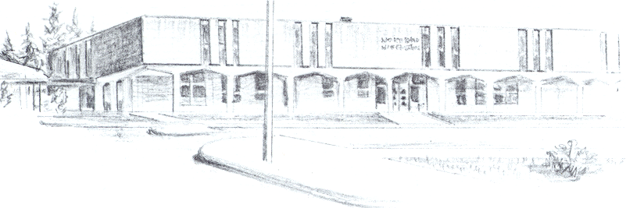

NORTH BEND HIGH SCHOOL
2323 Pacific Avenue
North Bend, Oregon 97459-2605
Telephone: 541-751-7159
Fax: 541-756-8322
A N I M P O R T A N T S C H O O L I N T H E N O R T H B E N D S Y S T E M O F P U B L I C E D U C A T I O N

Our credit recovery plan for Zach Nix started at the beginning of this year. Zack is currently enrolled in several Credit Recovery classes at North Bend High School. So far this term he has recovered 5 classes. On top of that, he should receive an additional 5 credits from his regular classes here at North Bend High School. This will give him 20 credits at the end of the term (possibly more if he can make up another credit before the end of this term). Zach will need to stay in a credit recovery class next term. At the end of next term, we are hopeful that Zach will have 29 credits and be back on track to graduate.

