Madras High School
Home of the White Buffalos
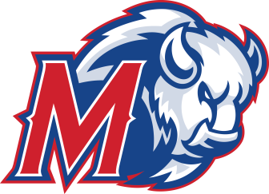

390 SE Tenth Street Madras, OR 97741 Principal: Mark Neffendorf
(541) 475-7265 • F: (541) 475-7744 Assistant Principals: HD Waddell & Nate Tyler
http://jcsd.k12.or.us/schools/mhs Athletic Director: Evan Brown

October 2, 2015

Progress report For Lyryk Webb

At this time of the school year we do not have progress to report as we are a proficiency based teaching and learning school.

Evan Brown,CAA
Athletic Director

