September 21, 2015

To whom it may concern —

The purpose of this letter is to explain the situation of Tiki McCollum, Jr. and to ask that he be considered for eligibility to represent Glencoe High School in athletics this school year. We have met with the counseling office and with the athletic director of Glencoe to discuss this. We understand the reasons behind the rule which currently makes Tiki ineligible for full participation in sports. But we are hoping that an exception might be made in his case.

Tiki has come to live with us here in Hillsboro and is studying at Glencoe for his senior year. While he loves his family in Portland—and they love him—certain circumstances in his home have led to the need for him to take up residence elsewhere. This began last spring, and he found himself “couch-surfing” in the homes of different friends through much of the second semester of his junior year. And with a lack of moral support, he found it easy to run with the sorts of friends who were less than the best influence on him. Understandably, his grades suffered.

Through our summer camp, our family has, over the past two years, come to know and love Tiki. We have worked with his mother to have him stay with us and for us to be his school guardians. As he has lived with us for the past two months or so, we have found Tiki to be an exceptionally bright, hard-working, respectful and thankful young man. He understands the good situation he has been given and truly wants to make the most of it. Indeed, when he was in the midst of his unhappy life situation in the spring, it was Tiki himself who reached out and made contact with good people to get help and to improve his situation.

Tiki is a fine athlete and the kind of young man for whom involvement in athletics becomes, not a distraction from academics, but a fuel for it. Still, we will be monitoring his progress with the faculty and counseling department of Glencoe to make sure he stays on track for graduation. Should it become clear at any time that athletic participation is having a detrimental effect on his academics or other important areas of life, we will lovingly and firmly withdraw him from sports.

So with this in mind, we ask that you consider clearing Tiki to play sports this fall and winter.
If you have any questions, please do not hesitate to contact us at any time.
Thank you for your attention and consideration.
Sincerely,
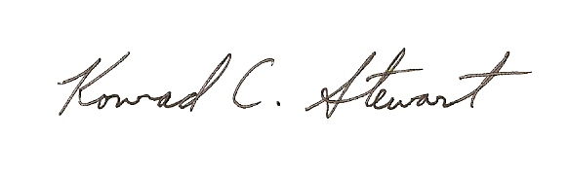

- KC (and Shelly) Stewart
(503) 681 – 2216
stewart@gmail.com

