Madras High School
Home of the White Buffalos
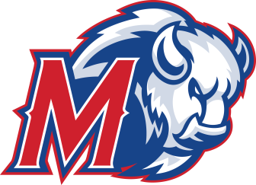

390 SE Tenth Street Madras, OR 97741 Principal: Mark Neffendorf
(541) 475-7265 • F: (541) 475-7744 Assistant Principals: HD Waddell & Nate Tyler
http://jcsd.k12.or.us/schools/mhs Athletic Director: Evan Brown

September 17, 2015

Progress report For Jonathan Reynoso

At this time of the school year we do not have progress to report.
We just started school!

Evan Brown,CAA
Athletic Director

