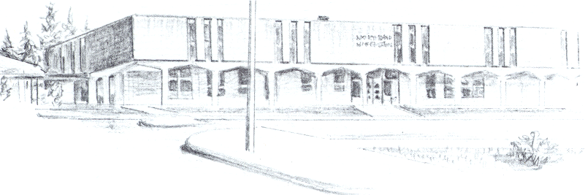

NORTH BEND HIGH SCHOOL
2323 Pacific Avenue
North Bend, Oregon 97459-2605
Telephone: 541-751-7159
Fax: 541-756-8322
A N I M P O R T A N T S C H O O L I N T H E N O R T H B E N D S Y S T E M O F P U B L I C E D U C A T I O N

To: Tom Welter

From: Mike Forrester

Re: Hardship request for Vanessa Gajdosova

North Bend High School supports the efforts of Vanessa Gajdosova to participate in extra curricular activities at North Bend High School. In our community, it is hard to find people to take Foreign Exchange students. This year, for the first time, I have seen signs around town asking for families to volunteer to host foreign exchange students.

Sara Van Vlack and her family, who live in Coos Bay stepped up and volunteered to host a family. Sara however works for a family who has students who attend North Bend Schools and she transports them to and from school and attends numerous events at North Bend Schools because the children that she takes care of are involved in those activities.

Sara, knowing that if she were going to host a Foreign Exchange student would want them to attend North Bend Schools, was forward thinking and took care of all of the IDT paperwork before Vanessa even arrived in the United States.

We appreciate the fact that Sara was willing to take on a Foreign Exchange student and took care of all of the paperwork before Vanessa even arrived here in America. We believe that Vanessa should be able to participate in athletics and activities here at North Bend High School. We believe it will be a great experience for her as a Foreign Exchange student and big part of a positive time here in the United States. Thank you for your consideration.

Sincerely,

Bill Lucero
Principal
North Bend High School

