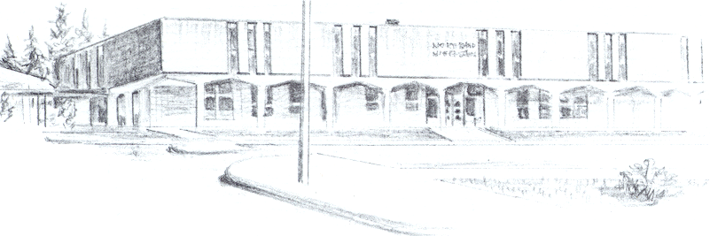

NORTH BEND HIGH SCHOOL
2323 Pacific Avenue
North Bend, Oregon 97459-2605
Telephone: 541-751-7159
Fax: 541-756-8322
A N I M P O R T A N T S C H O O L I N T H E N O R T H B E N D S Y S T E M O F P U B L I C E D U C A T I O N

To: Tom

From: Mike Forrester

Re: Austin Barker

North Bend High School supports the efforts of Austin Barker to participate in athletics during the 2015-16 school year. Last spring, Austin did not pass 5 classes as required by the OSAA. Austin only passed 4 of the six classes that he took. This is not typical of Austin, and we are hopeful that it will not happen again.

Austin is a nice young man, very polite, and respectful of adults and fellow students. Austin hopes to play soccer this fall at NBHS. Austin understands that if the OSAA allows him to participate, he must meet some other requirements set forth by us at NBHS. We will do a weekly grade check, and if he is failing a class, Austin will not be allowed to participate in any games until he is passing all of his classes.

We know that Austin is a very capable athlete that should do fine academically this fall. Austin understands that we will not be coming back to the OSAA in the future for him if he does not pass at least 5 classes at some future point over the next 2 years.

Sincerely,

Michael R. Forrester
North Bend High School
Athletic/Activities Director

