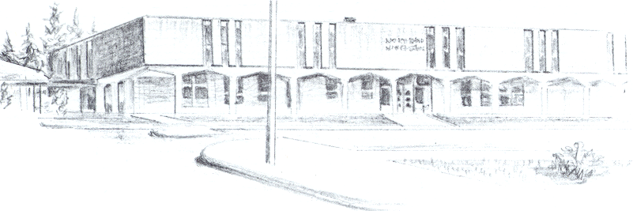

NORTH BEND HIGH SCHOOL
2323 Pacific Avenue
North Bend, Oregon 97459-2605
Telephone: 541-751-7159
Fax: 541-756-8322
A N I M P O R T A N T S C H O O L I N T H E N O R T H B E N D S Y S T E M O F P U B L I C E D U C A T I O N

To: Tom Welter

From: Mike Forrester

Re: Graham Lyons

North Bend High School supports the effort of Graham Lyons to participate in athletics this year. Graham is going to be a sophomore this year at our school. Last year, Graham had the opportunity to travel to New Zealand with another family during part of our school year. While in New Zealand, Graham attended a school, but also completed some credit recovery classes here at North Bend High School. He returned to North Bend a few weeks before the school year was up and attended classes at the end of the year.

Graham is an outstanding young man with very good grades as well. While he was in New Zealand, he attended classes, but the only credits he completed were the ones he did online for our school. As you can see on his transcripts, his grades are well above average.

When Graham got back to North Bend, his parents wanted to know if they should re-enroll him before the end of the year and we told them yes. We thought it was important to have him come, even though we knew he would not complete any classes before the end of the year. Graham is not a student we would worry about not being eligible because of not making adequate progress toward graduation.

This was a very unique opportunity for Graham to experience another part of the world and we believe that he had a great experience. We hope that the OSAA supports Graham and allows him to participate at North Bend High School this year.

Sincerely,

Mike Forrester
North Bend High School
Athletic/Activities Director

