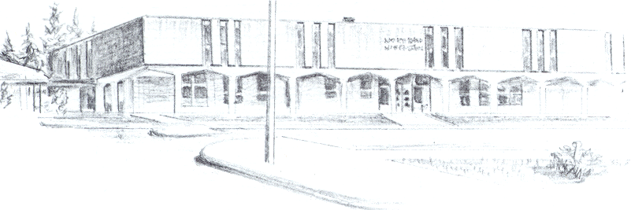

NORTH BEND HIGH SCHOOL
2323 Pacific Avenue
North Bend, Oregon 97459-2605
Telephone: 541-751-7159
Fax: 541-756-8322
A N I M P O R T A N T S C H O O L I N T H E N O R T H B E N D S Y S T E M O F P U B L I C E D U C A T I O N

To: Tom

From: Mike Forrester

Re: Cody Miller

North Bend High School supports the effort of Cody Miller to participate in athletics this year. Cody is currently ineligible to participate because he did not pass 5 classes last term and he is not making adequate progress toward graduation.

Cody is currently on an IEP. Cody gives us a sincere effort but does struggle academically and socially to complete academic work in his classes. Cody also has some behavioral issues that we work on with him. We believe that it is very important for Cody to be involved in some type of extra curricular activities.

Sincerely,

Michael R. Forrester
North Bend High School
Athletic/Activities Director

