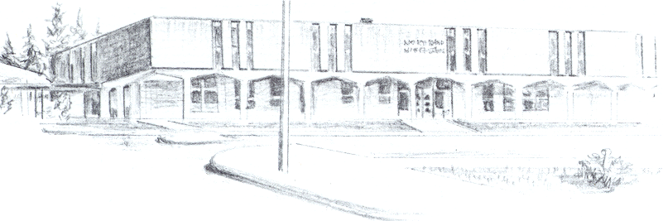

NORTH BEND HIGH SCHOOL
2323 Pacific Avenue
North Bend, Oregon 97459-2605
Telephone: 541-751-7159
Fax: 541-756-8322
A N I M P O R T A N T S C H O O L I N T H E N O R T H B E N D S Y S T E M O F P U B L I C E D U C A T I O N

To: Tom Welter
From: Mike Forrester
Re: Jacob Escalante

North Bend High School supports the efforts of Jacob Escalante and his parents, Alicia and Eric Escalante to participate in athletics this year at North Bend High School. While Jacob has not started school yet, he would like to be able to participate on the football team this fall. Jacob’s situation is a very unique one. During his sophomore year, he became involved in a sexual relationship with one of his teachers at Bainbridge High School.

As you can imagine, this relationship has created some issues in Jacob’s life that did not allow him to continue with school last year in Bainbridge Island. He did attend Marshfield for a short time, but was not able to function there. Jacob’s parents are looking for a way to get him a fresh start this year and hopefully turn his academic and social life around.

Jacob and his family do not live within the North Bend School District boundaries. They have received an IDT which will allow him to attend school in North Bend. Because of this IDT, Jacob will sign a contract with us with some stipulation included. Those stipulations are the Jacob will need to maintain at least a 90% attendance rate and he may not have any major discipline violations. Failure to comply with either of these will result in his IDT being revoked.

We are aware that Jacob will need to do some work to catch up on classes he has missed out on. Our plan at this point is to include in Jacob’s classes some credit recovery classes, possibly summer school if needed, and some work experience classes after school hours to help him get back on track to graduate. We will also monitor Jacob’s grades weekly and require him to be passing all of his classes each week in order to play in games.

Obviously, this is a very unique situation, but we would like to give Jacob a real chance to be successful and get his life headed in the right direction. Please contact me if you have any other questions that I can answer.

Sincerely,

Michael R. Forrester
North Bend High School
Athletic/Activities Director

