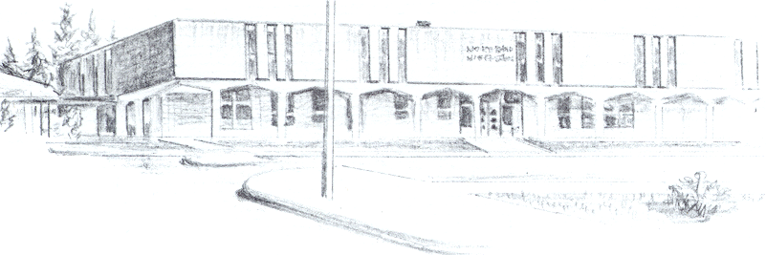

NORTH BEND HIGH SCHOOL
2323 Pacific Avenue
North Bend, Oregon 97459-2605
Telephone: 541-751-7159
Fax: 541-756-8322
A N I M P O R T A N T S C H O O L I N T H E N O R T H B E N D S Y S T E M O F P U B L I C E D U C A T I O N

To Whom It May Concern:

North Bend High School is appealing the ejection of Jake Simmons that occurred on Thursday, September 17th, during the North Bend High School/ Marist High School JV football game. We have the video clip of the entire play. It takes place in plain view of the camera. There are 5 reasons that we are appealing this call.

- The 2 players involved were running side by side during the play. Our player visibly clipped the player from Marist. That was not what the call was however. Our players was ejected because he “launches himself into back of Marist player ,injuring him rendering him unable to continue Flagged for flagrant blindside block and ejected.”
- The player from Marist that was injured on the play was not the player that got blocked, but was the initial player that tried to make the tackle on our punt returner well before this contact happened. The player that was blocked got up continued in the play, while the player that was never even touched (our punt returner made a move to get by him and the boy from Marist tripped and suffered a leg injury) had to be attended to. In addition, the Marist player is not only not hurt, but he gets up and runs back down field to try to make a tackle and in the process possibly even clips a North Bend Athlete.
- The official that made the call said that our player “Launched himself into the back of the Marist player.” Nothing could be further from the truth. The two players involved were wide-outs covering the punt. The players were running right next each other and were either in contact or were very close to being in contact the entire play. I believe that our player “clipped” the player from Marist, but this is not even close to a “Blindside block.”
- There was an official about 10 yards away from the play and with his eyes on the block and nothing between him and the play. While he should have thrown his flag, he did not. The call came from the other side of the field where there were definitely possibilities of players obstructing his view.
- Finally, our player blocked a player that was in a great position to make a tackle on our punt returner. The players were about 6 yards away from the ball when the contact happened. My understanding is that when a Blindside Block does occur, which it did not here, an athlete may be ejected if they make that block away from the play and with malicious intent to injure another athlete. This contact did not occur away from the play. Again, we have no question about this being a “Clipping” penalty.
North Bend High School feels without a doubt that there was a mistake made on this call. While we believe there was a penalty that occurred on the play, the play was a “Clipping” penalty and not a “Blindside Block.” Furthermore, there was no malicious intent by our player to hurt another player. This contact warranted a penalty, but to eject an athlete for this contact is a mistake that should be overturned. Thank you for your consideration.
Sincerely,

Mike Forrester
North Bend High School
Athletic/Activities Director

